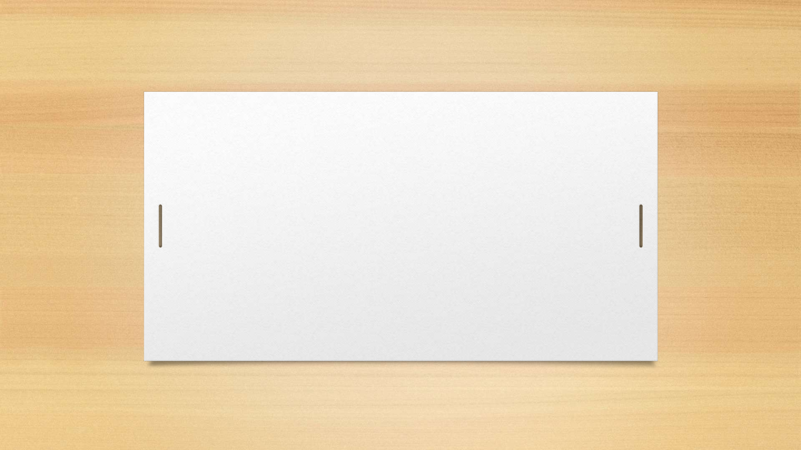

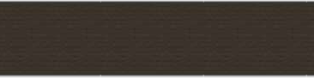
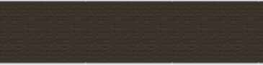
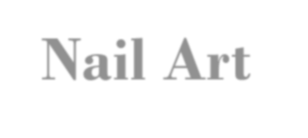
Nail Art
Made By : Nail Art Web

Nail Art
 | Supervisor | Sir Adil
 | Batch | 2508e
 | Group | Nail Art
 | Enrollment No: | Student Name:
 | 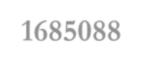  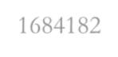  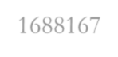  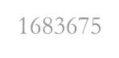  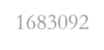  1685088 | Abdul Rehaman (Leader)
 | 1684182 | Narand Chohan
 | 1688167 | Mohammad Minhal
 | 1683675 | Ahmed Tariq
 | 1683092 | Mohammad Haseeb
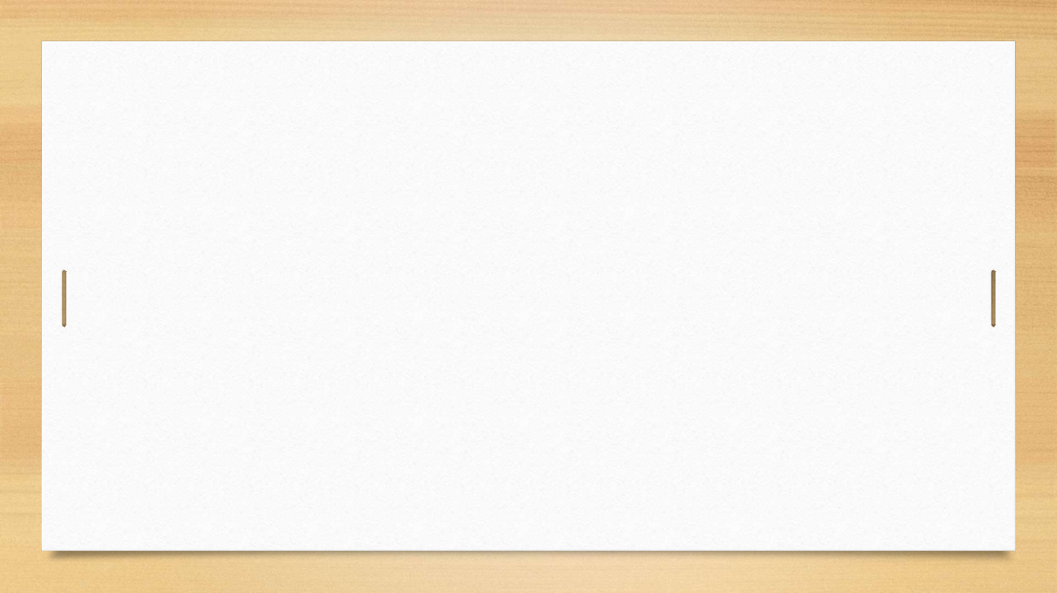
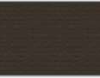
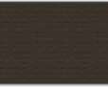

Nail Art – Acknowledgement
- First, we would like to express our special thanks and gratitude to our teacher Sir Adil, who helped us a lot in finalizing this project within the limited time frame. His valuable guidance, continuous support, and encouragement played a major role in the successful completion of this project.
- Secondly, we would like to thank the E-project team at Aptech Head Office for giving us the opportunity to work on this interesting and wonderful project based on The Nail Art Website. This project helped us gain practical knowledge and enhanced our creativity in designing and developing a professional website related to nail art.
- Thirdly, we also thank the e-project team for assigning us this task, which helped us improve our technical and analytical
skills.
- Benefits of This Project:
- Re-enforcement of skills through the experiential learning process.
- Continuous guidance from a mentor, ensuring we stayed focused and on the right path.
- Increased confidence to face interviews, as we have worked on a complete project and can clearly explain the concepts we have learned.

Nail Art - Synopsis
- The project “The Nail Art Web” is a creative and responsive website designed to showcase the beauty, creativity, and latest trends of nail art through a modern digital platform. The main aim of this project is to create a colorful, user-friendly, and engaging website where users can explore different nail art designs, view galleries, read updates, and interact through various sections.
- The website consists of several pages such as Home, About Us, Gallery, Nail Art Designs, Services, Upcoming Trends, News & Updates, Membership, Login, Register, Feedback, and Contact. Each page is designed with an attractive nail art theme, soft yet vibrant colors, and a clean layout to provide users with a pleasant and stylish browsing experience.
- The project is developed using HTML5, CSS3, Bootstrap 5, and JavaScript, ensuring that the website is fully responsive and works smoothly on all devices. The design includes features such as overlay backgrounds, animations, and interactive elements that make navigation smooth, modern, and visually appealing.

Nail Art – Problem Definition
- In today’s busy world, people often miss out on discovering new nail art designs, trends, and creative ideas due to lack of time, awareness, or access to updated information. There is a need for a digital platform that brings all nail art-related information, visuals, and updates into one place in an attractive and easy-to-use format.
- Many existing websites are either too simple or lack a creative design that truly showcases the beauty and creativity of nail art. Users find it difficult to explore designs, stay updated on the latest trends, or learn new techniques in an organized and enjoyable way.
- The main problem identified was the absence of a single, interactive, and responsive platform where users can:
- Explore a wide variety of nail art designs and styles.
- View images, tutorials, and design ideas.
- Stay informed with the latest trends and updates in nail art.
- Share feedback or connect through contact forms.
- Therefore, The Nail Art Web was developed to solve this problem by providing a colorful, responsive, and user-friendly
website that combines design, creativity, information, and interactivity in one platform.

Nail Art – Scope Of The Work
- The scope of The Nail Art Web project is to design and develop a responsive, attractive, and user-friendly website that provides complete information, galleries, and updates about nail art designs, trends, and services. This project covers all major aspects of a modern web platform, including design, functionality, and user experience.
- The main scope of work includes:
- 1. Website Design & Development
- Creating multiple pages such as Home, About Us, Nail Art Designs, Gallery, Services, Membership, Login, Register, Feedback, and Contact.
- Using HTML5, CSS3, Bootstrap 5, and JavaScript for building and styling the website.
- 2. Responsive Layout
- Ensuring the website works perfectly on all screen sizes, including mobile, tablet, and desktop.
- 3. Dynamic and Interactive Sections
- Adding sections like Latest Designs, Upcoming Trends, News & Updates, and User Feedback for real-time engagement.
- 4. User Interaction
- Allowing users to register, log in, and provide feedback easily through simple, validated forms.
- 5. Visual Appeal
- Designing an eye-catching interface with vibrant nail art themes, high-quality images, and subtle animations to enhance user experience and engagement.

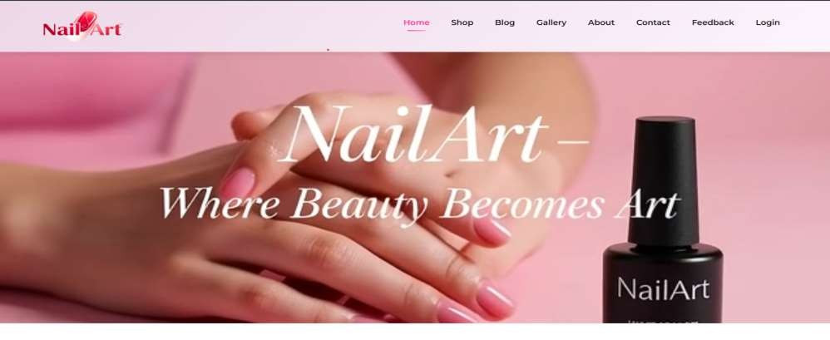
Nail Art – Our Website (Home Page)

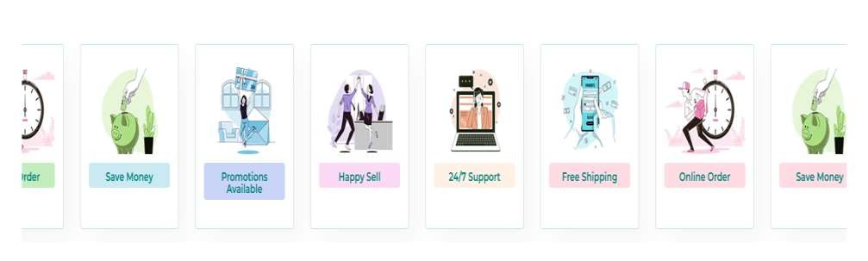
Nail Art – Our Website (Features)

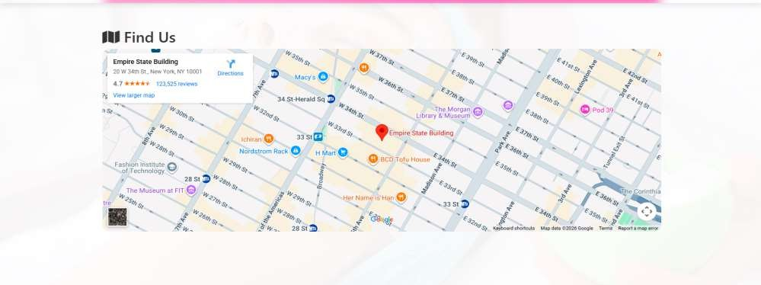
Nail Art – Our Website (Location )

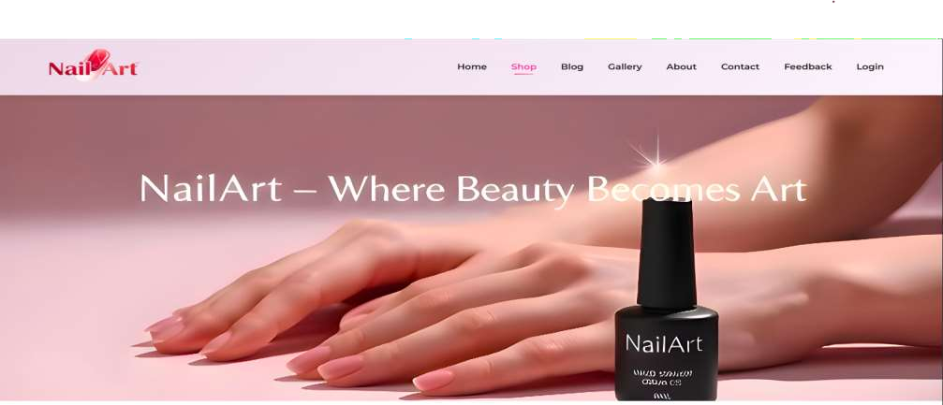
Nail Art – Our Website (Shop Page)

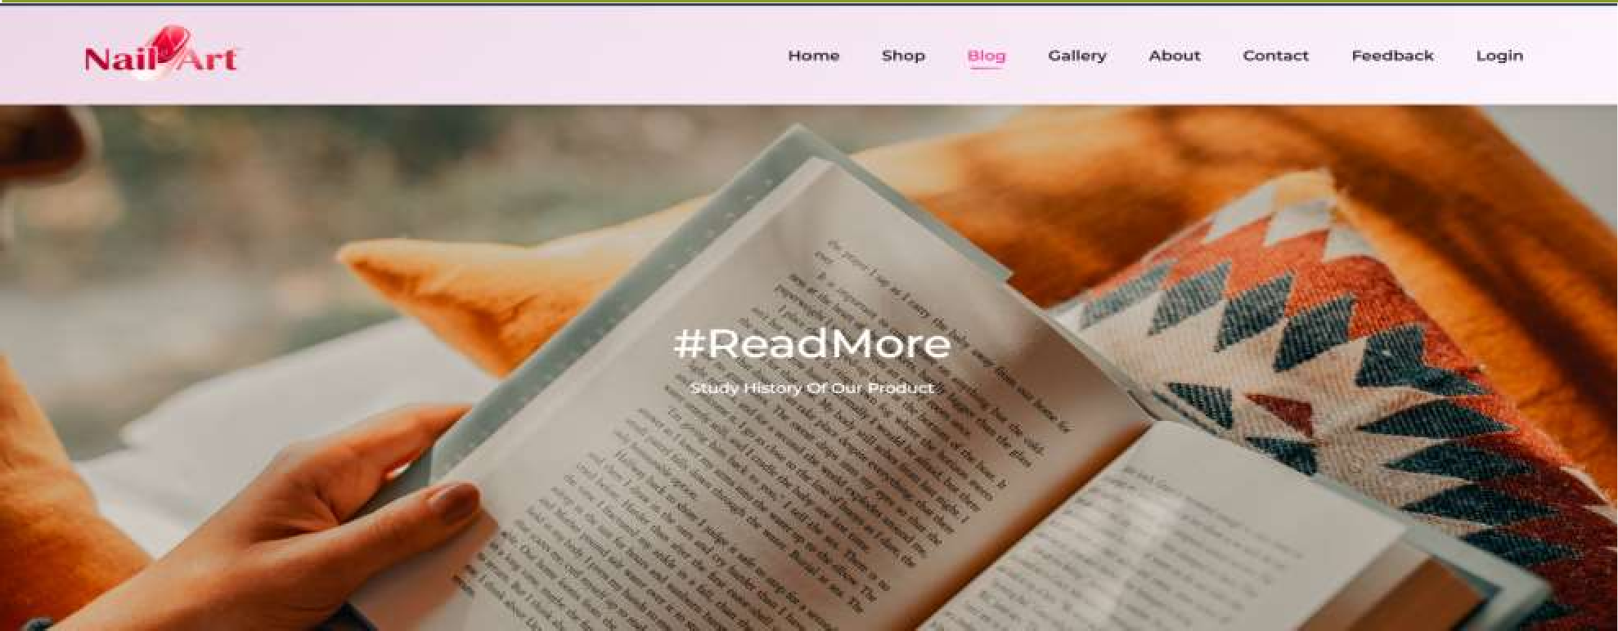
Nail Art – Our Website (Blog Page)

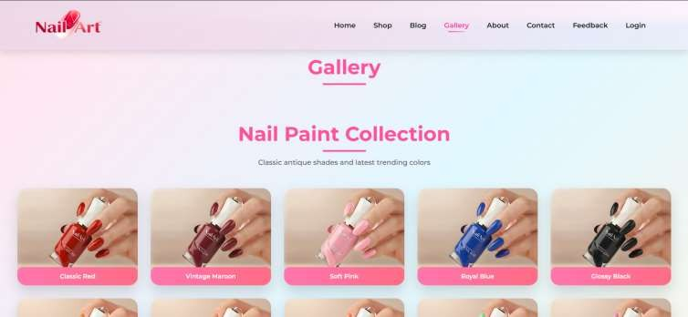
Nail Art – Our Website (Gallery Page)

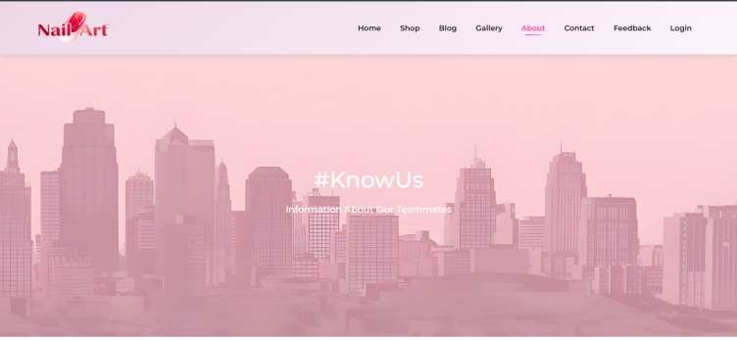
Nail Art – Our Website (About Page)

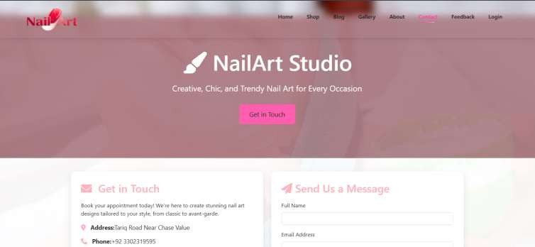
Nail Art – Our Website (Contact Us Page)

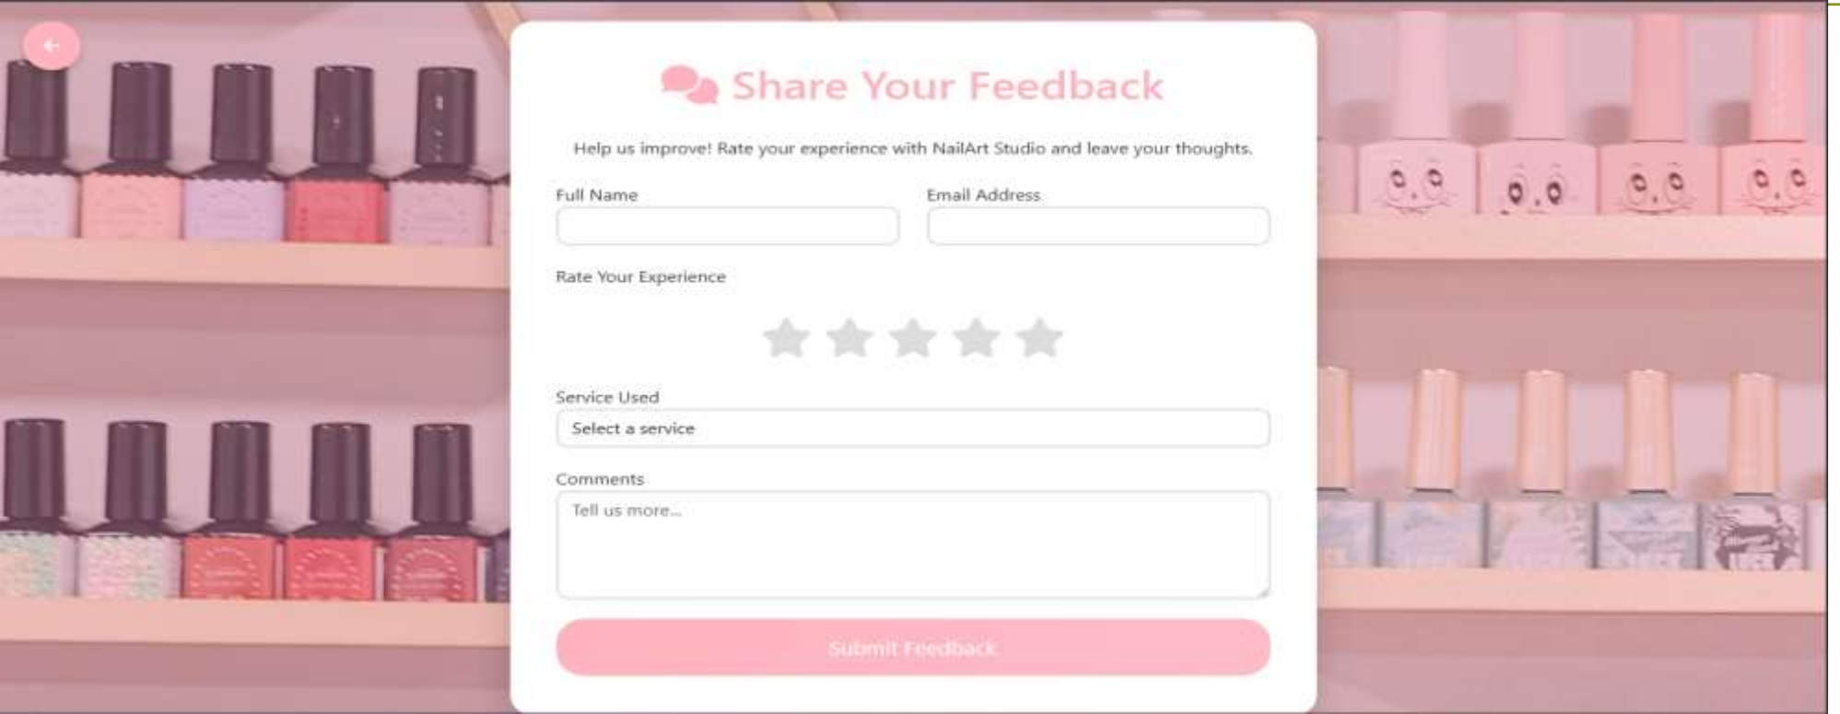
Nail Art – Our Website (Feedback Page)

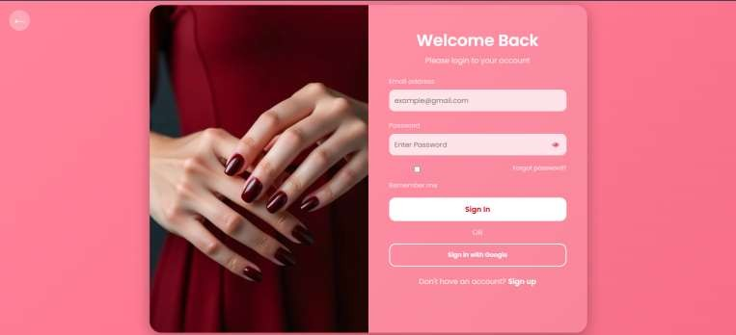
Nail Art – Our Website (Login Page)

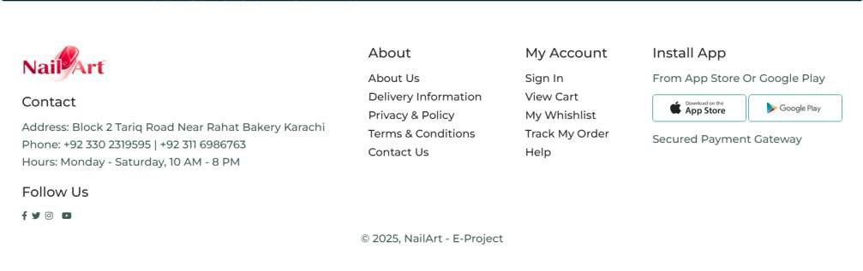
Nail Art – Our Website (Footer )



